Font Tutorial

Welcome to the AT&T Hackathon! Here is a basic tutorial guide on how to add AT&T fonts into your projects. Using AT&T fonts will be important if you want to score as many points as possible for judging as it is part of the rubric that is being judged.

# Basic HTML Program

Below is an example of a snippet of a basic HTML program. This will be the baseline on what the tutorial will be using to look at how to include the font. The code will be followed by an example of what it will look like in the website view.

The most important part will be to add the CSS (Cascading Style Sheets) through what is written below in the line with the red box.   
  
index.html

# 

Web View

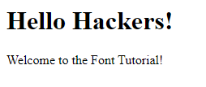

# How To Add A .ttf File Into Your Project

The next step is to make sure to add the .ttf file to your project directory so that you can use it like the image below.

Project Directory

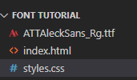

Once you have the .ttf file within your project, you can create a font-face for the given font. The font-family property will be how you will be referencing the font within the css file. The src property is the path to where the .ttf file is. You can then use the created font with .css classes, elements, and IDs.

styles.css

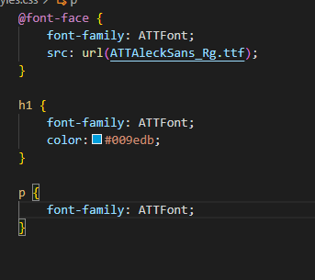

Web View

